How To Make Patient Carrying Element for XBX SERIES AMBULUX

Step 1:

*Figure 1: Picture of a 3x3x4 rectangular box.*

Step 2:

Cut a rectangular prism from the polyethylene material, measuring 1x1x2 inches, below the 4-inch-long part of the prism.

*Figure 2: Picture if the rectangular prism with 1x1x2 inch gap in the bottom*

Step 3:

Create a 1.7x1.7-inch space with a 1.5 inch deep cut to hold the egg securely. Referring to the image below, position the cutout 0.70 inches above the bottom side and 0.65 inches from the right and left sides when viewed from the top. The side view shows the 1.5-inch-deep cut.A picture containing chart

*Figure 3: The pictures show the dimensions of the cuts and where they are located.*

Step 4:

Wrap tape around the Patient Carrying Element to slightly reduce the space size of the hole where the egg will be placed. This will help hold the egg and make the structure firm.

*Figure 4: picture shows the egg and the Patient Carrying Element wrapped in tape.*

Step 5:

Acquire some white paper and cover the top, bottom, and sides of the Patient Carrying Element, leaving a gap only where the egg must be placed and a few gaps behind it. Also, draw a plus sign on both the right and left sides of the carrying element for aesthetic purposes.

*Figure 5: Picture of the patient carrying element covered with white paper and a plus sign drawn on it.*

Step 6:

Attach a 3-inch double-sided Velcro strip to the bottom of the box and another one on top of the ELEGOO robot car's battery to prevent it from falling out.

*Figure 6 and 7: Picture of the Velcro attached on top of the battery and under the patient carrying element.*

Step 7:

Attach the Patient Carrying Element onto the battery of the robot car.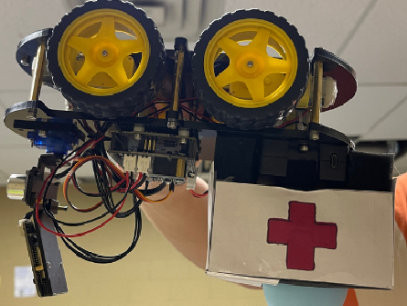

*Figure 8: Picture of both the car and the patient carrying element attached together.*